
Employee Engagement & Feedback Platform


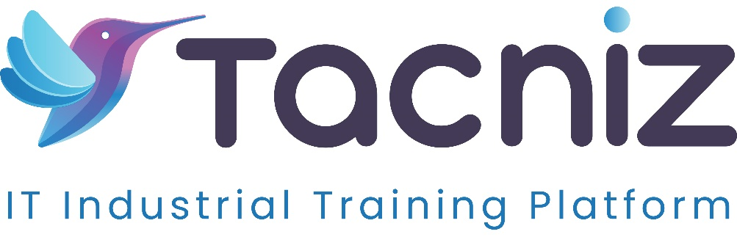
Problem Statement
In many organizations, employee engagement and satisfaction issues go unnoticed until they manifest as high turnover rates, absenteeism, or decreased productivity. Traditional feedback systems are often slow, infrequent, and lack the anonymity required for honest employee input. There is a need for a real-time platform that enables employees to provide feedback on their workplace experience, satisfaction, and challenges anonymously, allowing HR teams to proactively address issues and improve overall employee engagement.
Project Type
- Type: HR Engagement and Feedback System
- Category: Employee Satisfaction, Real-Time Feedback, Sentiment Analysis
Industry Area
- Industry: Corporate, IT, Education, Healthcare
- Relevant Sectors: HR Management, Employee Engagement, Workforce Development
Software Expertise Required
- Frontend Development: HTML, CSS, JavaScript (React, Vue, or Angular) for creating an intuitive interface where employees can submit feedback and HR teams can review engagement data.
- Backend Development: Node.js / Python (Django/Flask) for collecting and processing employee feedback, running sentiment analysis, and storing survey responses securely.
- Sentiment Analysis and NLP: Machine learning models for natural language processing (NLP) and sentiment analysis to assess employee comments and provide insights into workplace satisfaction.
- Survey Tools: Develop or integrate survey tools that allow HR teams to create customizable surveys and polls, collect anonymous responses, and analyze results.
- Data Visualization: Tools like D3.js or Chart.js for creating visual reports on employee engagement trends, challenges, and overall satisfaction.
- Cloud Integration: AWS, Google Cloud, or Azure for securely storing feedback data and providing real-time updates to the engagement dashboard.
- Security and Privacy: SSL/TLS encryption, anonymization tools, and strict access control to ensure that sensitive employee feedback is protected and anonymous.
Use Cases
- Employees: Provide real-time, anonymous feedback on workplace satisfaction, challenges, and engagement, ensuring their voices are heard without fear of retaliation.
- HR Teams: Collect and analyze employee feedback on various aspects of the workplace, including satisfaction, engagement, and company culture, to identify areas for improvement.
- Managers: Gain insights into team morale, track employee challenges, and use the data to foster a positive and productive work environment.
Expected Outcomes
- Real-Time Employee Feedback: Employees can submit feedback on their work experience, satisfaction, and concerns, enabling HR teams to collect and respond to issues promptly.
- Anonymous Surveys: The platform will offer HR customizable anonymous surveys to assess engagement, satisfaction, and employee concerns, fostering more honest feedback.
- Sentiment Analysis: The system will analyze employee feedback using sentiment analysis to gauge overall morale and detect common themes or concerns.
- Data-Driven Engagement Strategies: HR teams will have access to detailed reports and analytics, allowing them to create data-driven strategies for improving employee engagement and workplace satisfaction.
Key Features
- Anonymous Feedback Submission: Employees can submit feedback anonymously, ensuring that they feel comfortable providing honest input about their workplace experience.
- Real-Time Feedback Collection: Employees can provide feedback on an ongoing basis, helping HR teams address issues before they escalate.
- Sentiment Analysis: The platform uses natural language processing (NLP) to analyze the sentiment behind employee comments, helping HR identify overall morale and key pain points.
- Customizable Surveys and Polls: HR teams can create and distribute anonymous surveys and polls to collect targeted feedback on specific topics, such as workplace culture, management, or benefits.
- Engagement Reports: HR teams receive visual reports on employee satisfaction, challenges, and engagement levels, allowing them to track trends and identify areas for improvement.
- Automated Alerts: The system can notify HR when employee feedback reveals urgent issues, such as low morale, high levels of dissatisfaction, or recurring challenges.
Benefits
- Increased Employee Engagement: Employees are more likely to engage when they have a platform to voice their opinions and see that their feedback is valued and acted upon.
- Improved Workplace Culture: By analyzing employee sentiment, HR teams can address key issues that affect workplace culture and morale, fostering a healthier work environment.
- Proactive Problem Solving: Real-time feedback allows HR to identify and resolve issues before they negatively impact employee retention, productivity, or satisfaction.
- Anonymous Feedback for Honesty: Anonymous surveys and feedback channels encourage more honest input from employees, leading to more accurate data on engagement and challenges.
- Data-Driven HR Decisions: HR teams can use the feedback data to make informed decisions on workplace improvements, policy changes, and employee engagement strategies.
- Better Retention Rates: By addressing employee concerns early, the system helps improve job satisfaction and reduce turnover rates.
Project Duration
- Estimated Duration: 5-6 Months

